Efficient Pre-Inference Sanitization Architecture for Multimodal PII Protection Using Vision-Language Models

Diash Firdaus¹, Muhammad Ichwan², Fathurrahman Pratama Putra^{3*}, Riandika Fildani⁴
^{1,2,3,4} Department of Informatics, National Technology Institute of Bandung, Indonesia

Article Info |  | ABSTRACT
Article history:  Received month dd, yyyy  Revised month dd, yyyy  Accepted month dd, yyyy |  | Multimodal data processing using Vision-Language Models (VLMs) presents critical privacy challenges due to the complex exposure of Personally Identifiable Information (PII) within integrated visual and textual elements. Pre-inference protection is essential to mitigate data leakage risks, especially for privacy mechanisms in resource-constrained edge computing environments. This study proposes an Efficient Pre-Inference Sanitization architecture to detect and mask multimodal PII before VLM processing. The system was evaluated based on privacy protection effectiveness, data utility preservation, and computational efficiency. Using synthetic E-KTP, ATS CV, invoice, MCU, official letter, and customer letter datasets, three models were tested: Gemma3:4b, LLaVA-Phi3:3.8b, and Qwen3-VL:4b-Instruct. Results show Qwen3-VL:4b-Instruct achieved the highest analytical performance (87.4% composite score) but demanded substantial memory, with a peak VRAM of 9,547 MB. Conversely, Gemma3:4b emerged as a Pareto-optimal solution, maintaining competitive accuracy (83.6% composite score) with a peak VRAM of 5,061 MB. LLaVA-Phi3:3.8b demonstrated the lowest performance (33.6% composite score) due to failing on noisy visual datasets (2.9% extraction accuracy). These findings underscore a significant trade-off between privacy protection effectiveness and computational resource costs, highlighting that aligning model selection with hardware constraints is crucial. This research contributes to developing secure edge-based multimodal AI applications by balancing PII interception and semantic context utility.
Keywords:
Vision-Language Models (VLMs)
Personally Identifiable Information (PII)
Pre-Inference Sanitization Privacy Protection
Edge Computing
This is an open access article under the CC BY-SA license.

Corresponding Author:
Fathurrahman Pratama Putra
Department of Informatics, National Technology Institute of Bandung, Indonesia
Jalan PH.H. Mustofa No. 23, Kota Bandung, Jawa Barat
Email: fathurrahmanpratamap@gmail.com

- INTRODUCTION
The development of Artificial Intelligence (AI) in recent years has advanced rapidly with the emergence of Large Language Models (LLMs), which have a strong ability to understand and generate natural language [1]. These advances have subsequently driven a shift toward multimodal models capable of integrating various types of information, including text, images, and digital documents, within a unified processing framework [1], [2]. One significant development within this paradigm is Vision-Language Models (VLMs), which enable the simultaneous understanding of visual and textual information and have been applied to various tasks, such as document understanding, visual question answering, and multimodal document analysis [2], [3]. These capabilities make VLMs increasingly relevant for a wide range of scenarios involving visual and textual data simultaneously.
However, the enhanced ability of VLMs to understand multimodal content also increases privacy risks, particularly when the processed inputs contain Personally Identifiable Information (PII). Visual data may contain various types of sensitive information, such as faces, identification cards, passports, addresses, telephone numbers, email addresses, and QR codes that can be used to identify or track individuals [4]. Unlike text-based processing, PII in visual data is not always represented as text that can be directly recognized using conventional methods. Sensitive information may appear as objects, image regions, text embedded in documents, or combinations of visual and textual elements. These conditions make PII protection in VLM environments more complex because sensitive information may remain exposed even when one modality has been sanitized [2], [4].
Several approaches have been developed to detect and protect PII in digital data. For visual information, Optical Character Recognition (OCR), object detection, and image redaction are widely used to locate and obscure sensitive information in images and documents [3], [5]. For textual information, approaches based on Named Entity Recognition (NER), Large Language Models (LLMs), and text sanitization are used to identify and remove or replace sensitive entities while preserving relevant information [6], [7]. These approaches demonstrate that PII can be effectively protected within each modality. However, their effectiveness still depends heavily on the ability to extract information from the modality being processed.
This limitation becomes increasingly significant when data is provided to VLMs. Failures during the extraction stage, such as OCR errors or the failure to detect sensitive objects, can result in PII going unidentified and subsequently being passed to the inference stage. This leads to error propagation, in which errors at an early stage affect the success of the sanitization process at subsequent stages [2]. Conversely, overly aggressive redaction strategies may remove non-PII information that is still necessary to understand the context of a document or image. This issue creates a trade-off between privacy protection and the preservation of data utility. Consequently, sanitization systems must not only be capable of identifying PII but also preserve information relevant to multimodal understanding [8].
Although various studies have addressed PII protection in visual and textual data, most approaches are still designed to handle each modality separately [2], [3], [5], [7]. OCR-based and image-redaction approaches, for example, focus on protecting visual information, whereas NER and text sanitization are more commonly applied to textual data. This separation prevents systems from optimally accounting for the relationship between visual and textual information contained within a single multimodal input. Moreover, in some approaches, protection is implemented as part of or after the analysis process, meaning that sensitive data may already be accessible to the model before sanitization mechanisms are applied. This situation reveals two primary gaps: the lack of multimodal integration in PII sanitization and the failure to perform sanitization before data enter the VLM inference stage.
These challenges become more complex when protection mechanisms are implemented in edge computing environments. Local processing on edge devices offers the advantage of reducing the need to transmit sensitive data to external servers. However, such devices generally have more limited memory, computing power, and processing capacity than cloud infrastructure [9]. Therefore, PII sanitization mechanisms for VLMs must not only provide strong detection capabilities but also account for computational efficiency to enable practical deployment in resource-constrained environments.
To address these challenges, this study proposes an Efficient Pre-Inference Sanitization architecture for detecting and masking PII before data are provided to a VLM. Unlike approaches that handle modalities separately, the proposed architecture integrates visual and textual PII detection into a unified pre-inference sanitization pipeline. By performing sanitization before inference, sensitive information can be minimized at an early stage, ensuring that the VLM receives input that has already undergone protective processing. This approach is also designed to preserve relevant non-PII information so that sanitization does not excessively reduce data utility [8].
In addition to privacy protection, this study considers deploying the architecture in edge computing environments. The sanitization process is designed to run locally, ensuring that raw data containing PII does not need to be transmitted to external infrastructure before being protected. Accordingly, the proposed approach seeks to balance PII detection effectiveness, sanitization success rate, preservation of relevant information, and computational efficiency. This evaluation is necessary to ensure that the protection mechanism not only reduces PII exposure but also preserves the VLM’s ability to understand sanitized content.
The main contributions of this study are: (1) developing a multimodal PII sanitization mechanism at the pre-inference stage to protect inputs before the VLM processes them; (2) integrating PII detection and masking for visual and textual elements into a single pipeline; (3) designing a sanitization mechanism that preserves non-PII information to reduce the risk of overmasking; and (4) optimizing the sanitization process to support deployment in resource-constrained edge computing environments. Through this approach, the study is expected to provide a more integrated, efficient, and suitable privacy protection mechanism for deploying VLMs in multimodal applications containing sensitive information.

- METHOD
To ensure a systematic evaluation of the proposed document processing pipeline, this study designs a sequential methodological framework, as shown in Figure 1. The framework integrates document processing and privacy protection into a unified evaluation workflow, allowing the performance of each stage to be assessed before proceeding to the next process.

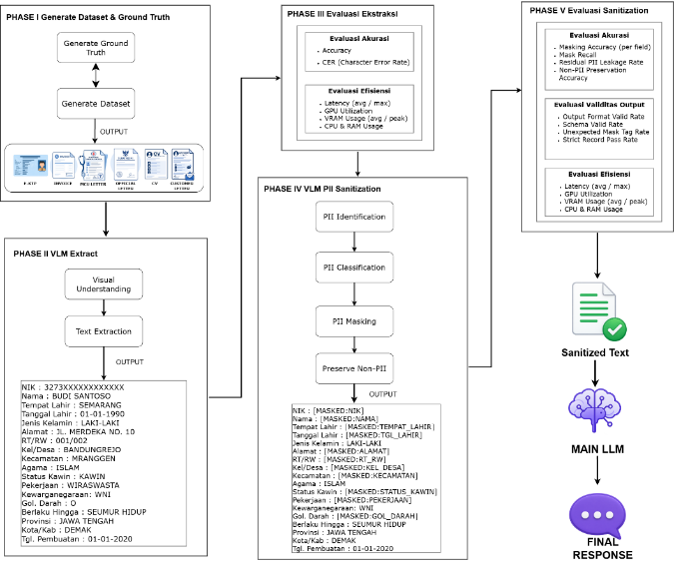
Figure 1. Proposed framework for document processing and privacy preservation.
The processing approach in this study integrates information extraction, performance evaluation, and PII sanitization into a single pipeline, as shown in Figure 1. The extraction results are first evaluated before being processed to remove sensitive information. The sanitized output is then validated to ensure information integrity and privacy protection before being passed to the main LLM.

- Generate Dataset & Ground Truth
The initial stage of the study focused on developing the ground truth as a reference for representing the expected information in each document. This reference served as the basis for comparison with the outputs of the extraction and PII sanitization stages, allowing changes and information consistency to be evaluated quantitatively. The ground truth was then used to create a dataset comprising Indonesian electronic identity cards (E-KTPs) and five types of administrative documents: invoices, official letters, ATS-friendly résumés, medical check-up (MCU) results, and customer letters.

    - E-KTP Dataset Generation
The synthetic E-KTP dataset was created through a structured process to generate diverse document images while preserving the key visual characteristics of E-KTP cards. The dataset creation process included template preparation, synthetic identity and facial image generation, geometric calibration, perspective transformation, and image compositing to simulate more realistic acquisition conditions. The overall dataset creation workflow is shown in Figure 2.
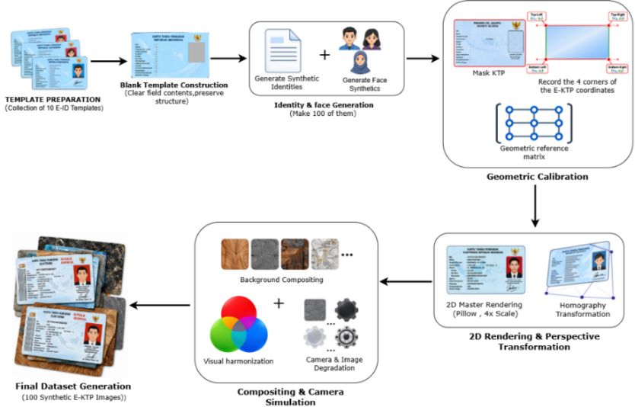
Figure 2. E-KTP synthetic dataset generation workflow
The synthetic E-KTP dataset was created incrementally through several integrated key phases, beginning with template preparation and ending with the generation of synthetic document images ready for use as a research dataset. In the first phase, 10 E-KTP templates were prepared as the basis for data generation by removing all information from each field while retaining only the documents’ visual structure. These blank templates then served as the primary framework for generating various document variations without using any real identity data [10], [11].
The next phase involved generating synthetic identities and faces to populate each template. This process produced 100 combinations of synthetic data consisting of identity information and facial representations, giving each document distinct visual characteristics. After all elements had been placed on the templates, geometric calibration was performed by defining the documents’ four corner points as spatial references. These coordinates served as reference points for maintaining consistent document positioning before the perspective transformation process [10], [11].
Next, the documents underwent master rendering at 4× scale to preserve the visual quality of each element before the homography transformation was applied. This transformation produced variations in document orientation and perspective, ensuring that the resulting images were not limited to frontal views. In the final phase, the transformed images were combined with various backgrounds through a compositing process, followed by visual harmonization and camera degradation simulation to reproduce image characteristics more closely resembling real-world acquisition conditions [12], [11]. This entire process produced 100 synthetic E-KTP images as the final dataset, with examples of the generated E-KTP images shown in Figure 3.
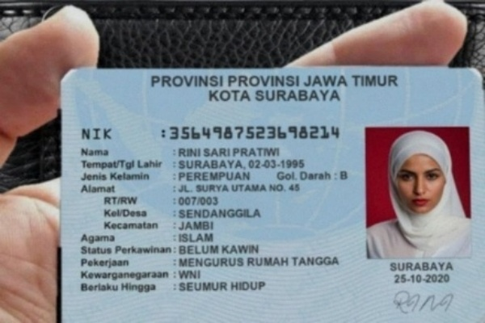
Figure 3. E-KTP Generation Results
    - Administrative Document Dataset Generation
The synthetic administrative document dataset was developed through a structured process to generate diverse documents while preserving the structural and visual characteristics of administrative documents. The dataset development process included template collection and analysis, synthetic entity generation, document content creation, template population and PDF rendering, layout calibration and field mapping, validation and quality control, document augmentation, and data packaging and export. The overall dataset development workflow is shown in Figure 4.
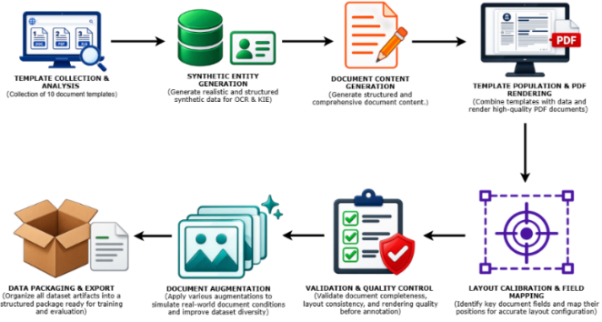
Figure 4. Synthetic administrative document dataset generation workflow
The Administrative Document Dataset Generation process was carried out through a series of integrated stages to produce a structured synthetic administrative document dataset with visual variations. The process began with the collection and analysis of 10 administrative document templates as the dataset’s foundational structures. Each template was analyzed based on its field arrangement, element positions, and layout characteristics, ensuring that the documents’ visual structure could be preserved without using real identity information [13], [10], [11].
Next, synthetic entities were generated to provide realistic and structured identity data and administrative attributes [13], [14]. These entities were then mapped to the templates through the document content generation process before being rendered as native PDF documents. This format, with its clean text structure, was deliberately selected to provide an evaluation contrast with the E-KTP image dataset, which contains visual noise. The rendered documents subsequently underwent layout calibration and field mapping to ensure that the information was positioned according to the template structure and remained consistent with the ground truth [14], [10].
The next stage involved validation and quality control to verify the completeness, consistency, and conformity of the generated documents. Documents that met the criteria were then augmented with visual variations, such as distortion, rotation, lighting changes, and variations in image quality, to represent a wider range of document conditions [12], [11]. In the final stage, all documents, along with their ground truth and metadata, were packaged into a standardized dataset structure, resulting in an Administrative Document Dataset consisting of 100 synthetic documents for each category (a total of 500 administrative documents). The dataset was then ready for use in training and evaluating information extraction systems based on Vision-Language Models (VLMs). The results of the Administrative Document Dataset generation process are shown in Figure 5.
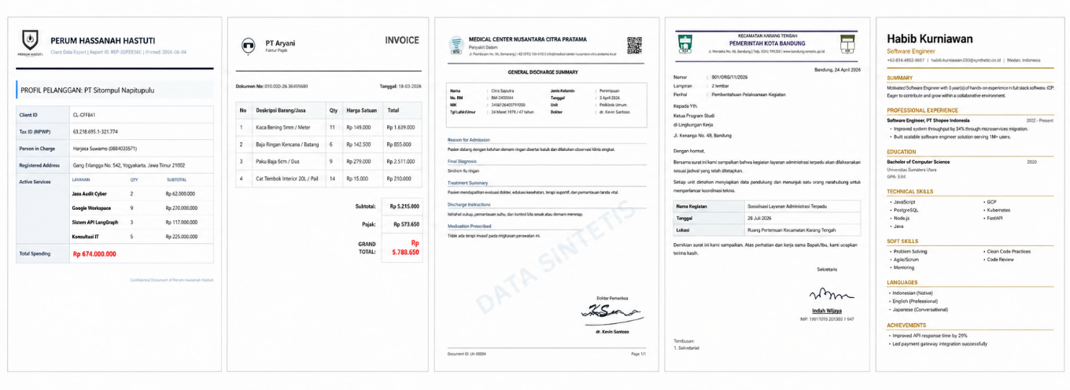
Figure 5. Administrative Document Dataset Generation Results
- VLM Extraction
The documents generated during the dataset creation stage are subsequently processed using a Vision-Language Model (VLM) to obtain textual representations of the information contained in the documents. The use of a VLM at this stage enables processing that simultaneously considers visual information and document context, so the extraction process focuses not only on character recognition but also on understanding how information is organized within the document. This process consists of two main stages: visual understanding and text extraction.
During the visual understanding stage, the VLM receives the document as visual input and analyzes its elements, including text, structure, and the relationships among those elements. The resulting visual understanding is then used during the text extraction stage to produce information in textual form. Thus, the output of the extraction stage represents information obtained from the source document in a format that can be processed in subsequent stages. For example, information from an Indonesian electronic identity card (E-KTP) can be extracted into structured attributes such as the national identification number (NIK), name, place and date of birth, gender, address, and other administrative information.
The VLM output at this stage is subsequently used as the basis for evaluating extraction quality against the previously established ground truth. In addition, the extraction results serve as input for the PII sanitization process, allowing information obtained from the documents to be identified and further processed according to its sensitivity characteristics. Within this workflow, the VLM Extraction stage serves as a bridge between the visual documents in the dataset and the textual representations required for evaluation and sanitization in subsequent stages. To evaluate the effectiveness of the proposed architecture under edge-computing constraints, this study implements and compares three lightweight VLM variants: Gemma3 (4B), LLaVA-Phi3 (3.8B), and Qwen3-VL-Instruct (4B). These three models were selected based on their state-of-the-art multimodal processing capabilities combined with efficient architectures. Meanwhile, Mistral Small Latest was designated as the Main Large Language Model (LLM) in the Untrusted Zone to perform final comprehension and summarization based on its ability to preserve the semantic context of the sanitized text.

- Extraction Evaluation
The output of the VLM Extraction stage is evaluated based on two main aspects: accuracy and computational efficiency. Accuracy evaluation aims to measure the correspondence between the extracted information and the ground truth, while computational efficiency evaluation is used to measure processing time and resource requirements during inference.
Accuracy is evaluated using Accuracy and Character Error Rate (CER), which are aggregated into Macro Accuracy and Macro CER to ensure balanced evaluation across document types. Accuracy measures the percentage of extraction results that match the ground truth; therefore, a higher value indicates greater extraction accuracy. Accuracy is calculated using the following equation [15] :
$\text{Accuracy}=\frac{N_{\text{correct}}}{N_{\text{total}}}$ (1)
where $N_{\text{correct}}$is the number of extracted results that match the ground truth, while $N_{\text{total}}$ is the number of extracted results that match the ground truth, while.
Meanwhile, the Character Error Rate (CER) measures the character-level error rate in the extraction results by accounting for substitutions, deletions, and insertions. A lower CER indicates that the extraction results more closely match the ground truth. CER is calculated using the following equation [16]:
$\text{CER}=\frac{n_{\text{errors}}}{n_{\text{characters}}}×100\%$ (2)

The computational efficiency evaluation includes latency, VRAM usage, and CPU and RAM utilization. Latency measures the time required for the VLM to process an input and generate an output; therefore, a lower value indicates faster inference. Latency is calculated using the following equation [9] :

$\text{Latency}=t_{\text{end}}-t_{\text{start}}$ (3)

where $t_{\text{start}}$ is the time at which the system begins processing the input, while $t_{\text{end}}$ is the time at which the system finishes generating the output.
VRAM usage indicates the amount of GPU memory used during inference. CPU and RAM utilization indicate the processor load and system memory usage during extraction, respectively. These efficiency metrics are obtained through direct measurements during inference and do not require specific mathematical formulations. The measurement of these resource metrics is specifically intended to validate the operational feasibility of the VLM under strict hardware constraints, which is an essential requirement for edge computing implementation [9].
These two evaluation aspects provide an overview of the VLM’s ability to produce accurate extraction results while remaining computationally efficient. The evaluation results are then used as a basis before the extraction output is forwarded to the VLM PII Sanitization stage.

- VLM PII Sanitization
The extracted text is then used as input for the VLM PII Sanitization stage. This stage is designed to separate information that must be protected from information that is still needed to preserve the document’s context. The sanitization process is performed sequentially through four stages: PII identification, PII classification, PII masking, and non-PII preservation.
During the PII identification stage, the VLM analyzes the extracted text to identify attributes containing Personally Identifiable Information (PII) [17]. The identification process examines the information in the extracted text to determine whether each attribute must be protected. Information identified as PII is then processed in the PII classification stage, where each identified attribute is assigned to a PII category. This stage maps the information in the document to the appropriate PII categories, which subsequently serves as the basis for the masking process.
The PII masking stage then replaces the original values of PII attributes with mask tags representing their respective categories. For example, the actual values of the National Identification Number (NIK) and name attributes are not retained in the output but are represented as [MASKED:NIK] and [MASKED:NAME]. This approach preserves the presence and structure of the attributes without exposing their sensitive values. At the same time, attributes that are not classified as PII are retained through the non-PII preservation stage, ensuring that contextual information such as gender, religion, occupation, or other administrative information remains available as long as it is not categorized as PII. The combination of these two processes produces sanitized text that preserves the document’s context while limiting the exposure of personal information..

- Sanitization Evaluation
The results of VLM PII Sanitization are evaluated based on two main aspects: accuracy and computational efficiency. The accuracy evaluation measures the accuracy of PII masking and the preservation of non-PII information, while the computational efficiency evaluation covers inference time and system resource usage.
The accuracy evaluation includes mask recall and non-PII preservation accuracy. Mask recall measures the system’s ability to detect and mask PII that should be protected [18]:
$\text{Mask Recall}=\frac{TP}{TP+FN}$ (4)
where $TP$(True Positive) is the number of PII fields that are successfully identified and correctly masked, while $FN$(False Negative) is the number of PII fields that should be masked but are not successfully identified or remain visible in the output, meanwhile, non-PII preservation accuracy measures the proportion of non-PII information successfully preserved in accordance with the ground truth [15]:

$\text{Non-PII Preservation Accuracy}=\frac{N_{\text{correctly preserved non-PII}}}{N_{\text{total non-PII}}}$ (5)

where $N_{\text{correctly preserved non-PII}}$is the amount of non-PII information successfully preserved in accordance with the ground truth, while $N_{\text{total non-PII}}$ is the total amount of non-PII information evaluated. All these sanitization metrics are then aggregated across documents to produce Global Mask Recall and Global Non-target Preservation.
The computational efficiency evaluation covers latency, VRAM usage, and CPU and RAM usage. Latency indicates the time required for the system to generate an output from an input and is calculated as follows [9]:

$\text{Latency}=t_{\text{end}}-t_{\text{start}}$ (6)

where $t_{\text{start}}$ is the time at which the system begins processing the input, while t_{\text{end}} is the time at which the system finishes generating the output.
VRAM usage indicates the amount of GPU memory used. CPU and RAM usage represent the processor and system memory loads, respectively, during the sanitization process. These metrics are obtained through system monitoring during inference to characterize the VLM’s computational resource requirements in edge-computing scenarios..
To facilitate the selection of an optimal model for the edge architecture, the evaluation in this study formulates a combined performance metric called the Composite Score. This score is designed to represent end-to-end performance quality holistically and measurably, from the text extraction stage (Phase 1) to the privacy sanitization stage (Phase 2). The Composite Score is calculated based on the average of three primary metric components: Macro Accuracy, which measures the accuracy of textual extraction against the ground truth; Global Mask Recall, which measures the percentage of PII entities successfully redacted; and Global Non-target Preservation, which measures the model’s precision in avoiding the overmasking of ordinary text. Integrating these three metrics aligns with the principles of modern privacy-system evaluation, which requires evaluation metrics to capture the trade-off between mitigating the risk of data leakage (privacy) and retaining information utility (utility) simultaneously, rather than focusing solely on accuracy. As an instrument for quantifying this trade-off, this study formulates the combined performance metric called the Composite Score in Equation (7) :
$CompositeScore=\frac{MacroAccuracy+GlobalMaskRecall+GlobalNon-targetPreservation}{3}$ (7)

The model with the optimal balance between the highest Composite Score and the lowest peak VRAM footprint will be identified using Pareto-efficient configuration analysis. [19]. This method is applied to evaluate system performance and efficiency. This multi-objective approach is used to extract a set of non-dominated solutions in order to explicitly map the trade-off between the accuracy of the model’s capabilities and hardware constraints. This methodology represents an essential optimization strategy within the edge-computing framework for balancing computational efficiency [9].
- System diagram
The system architecture is designed to process documents that may contain Personally Identifiable Information (PII) by separating sensitive data processing from processing performed using a Large Language Model (LLM). The system consists of a Trust Zone and an Untrusted Zone, which handle the processing of original documents and sanitized data, respectively. In this architecture, the Trust Zone represents the user’s local edge computing environment to ensure data privacy protection. In contrast, the Untrusted Zone represents the external cloud infrastructure where the main LLM operates.
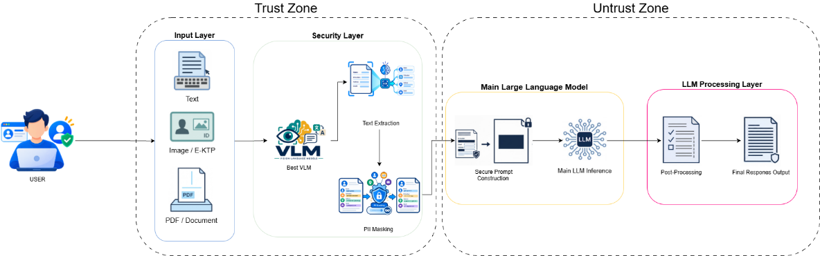
Figure 6. SanitiX-AI System Architecture
As shown in Figure 6, the system uses an architecture that separates sensitive document processing within the Trust Zone from language processing within the Untrusted Zone. The system workflow begins when a user submits a document as input. The document is received by the Input Layer and then forwarded to the Security Layer. At the Security Layer, a Vision-Language Model (VLM) is used to understand the document’s content and extract the information it contains. The extracted information is then used as input for the PII masking process, which obscures Personally Identifiable Information (PII) before the data leaves the Trust Zone.
After the PII masking process, the sanitized information is forwarded to the Untrusted Zone. The data is used in the secure prompt construction process to create a prompt for the main Large Language Model (LLM). Through this mechanism, the main LLM receives neither the original document nor the PII in its original form, but only information that has undergone a protection process. The main LLM then processes the prompt based on the available contextual information and generates a response according to the user’s needs.
The output from the main LLM is then forwarded to the LLM Processing Layer for post-processing. This stage performs final processing on the LLM’s response before producing the final response output.

- RESULTS AND DISCUSSION
3.1. VLM Text Extraction Performance
Before evaluating the text extraction capabilities of Vision-Language Models (VLMs), the initial phase of analysis must consider the systems’ computational efficiency. In a pre-inference sanitization architecture for edge computing environments, operational constraints—including latency and VRAM usage—are the primary determinants of real-time processing feasibility. Table 1 therefore provides a comprehensive overview of the computational efficiency of Gemma3:4b, LLaVA-Phi3:3.8b, and Qwen3-VL:4b-Instruct during the text extraction process. Based on these metrics, the three models exhibit different resource utilization patterns. LLaVA-Phi3:3.8b recorded the lowest latency (3.34 seconds on average, with a maximum of 6.59 seconds) but required the largest VRAM allocation (5,614 MB on average, peaking at 5,666 MB), posing a potential bottleneck for memory-constrained edge devices. In contrast, Gemma3:4b maintained moderate VRAM consumption (4,900 MB on average, peaking at 5,061 MB) but exhibited the highest latency (3.87 seconds on average, with a maximum of 9.37 seconds), indicating instability during spikes in computational workload. Meanwhile, Qwen3-VL:4b-Instruct emerged as the most computationally efficient architecture, operating with relatively low latency (3.40 seconds on average, with a maximum of 6.88 seconds) and the lowest VRAM usage (4,839 MB on average, peaking at 4,998 MB). Based on the combination of these two metrics, Qwen3-VL:4b-Instruct leads in computational efficiency. However, this hardware performance advantage becomes irrelevant if the extracted text is severely corrupted or unreadable. Therefore, to ensure that resource optimization does not compromise downstream data integrity, the evaluation was extended to analyze the text extraction accuracy of each model, as illustrated in Figure 7.

Table 1. Computational Efficiency of VLMs in Text Extraction
Variable | Latency (s) (Avg / Max) | VRAM Usage (MB) (Avg / Peak) | CPU (%) & RAM (MB) (Avg)
Gemma3:4b | 3.87 / 9.37 | 4900 / 5061 | 4.7% / 15001
LLaVA-Phi3:3.8b | 3.34 / 6.59 | 5614 / 5666 | 4.1% / 15510
Qwen3-VL:4b-Instruct | 3.40 / 6.88 | 4839 / 4998 | 3.8% / 15178

Figure 7 evaluates text extraction quality using two primary metrics: Macro Accuracy (Figure 7a) and Macro Character Error Rate (Macro CER, Figure 7b). The evaluation results reveal striking differences in the text extraction capabilities of the models across six document categories. Both Qwen3-VL:4b-Instruct and Gemma3:4b demonstrated exceptional performance on CV ATS and Customer Letters, achieving a Macro Accuracy of 100.0% (CER 0.0), indicating reliable character-level extraction. However, LLaVA-Phi3:3.8b demonstrated lower accuracy on CV ATS (60.3%, CER 0.2323) and Customer Letters (83.0%, CER 0.1253). For Medical Check-Up (MCU) and Invoice documents, the three models showed more competitive performance gaps. Gemma3:4b achieved the highest accuracy on Invoice (94.7%, CER 0.0268), outperforming Qwen3-VL:4b-Instruct (89.0%, CER 0.0889). Conversely, for MCU documents, Qwen3-VL:4b-Instruct led with 93.8% (CER 0.1505), compared with Gemma3:4b at 89.9% (CER 0.1445). Meanwhile, LLaVA-Phi3:3.8b showed the lowest performance, lagging behind on both MCU documents (80.8%, CER 0.2001) and invoices (74.3%, CER 0.2328). This indicates that variations in document layout—particularly the tabular structures in MCU documents and invoices—also affect reliability and extraction accuracy. A similar performance trend was observed for Official Letter and E-KTP documents. Qwen3-VL:4b-Instruct consistently maintained the highest accuracy on Official Letter (93.8%, CER 0.2649) and E-KTP (85.5%, CER 0.1374), followed closely by Gemma3:4b on Official Letter (89.3%, CER 0.2640) and E-KTP (82.1%, CER 0.0991). In contrast, LLaVA-Phi3:3.8b experienced a sharp decline on Official Letter (50.8%, CER 0.3326) and dropped significantly on E-KTP (2.9%, CER 0.8111). The comparison confirms that LLaVA-Phi3:3.8b’s processing speed advantage is not matched by stable accuracy at this stage. The extreme performance decline on E-KTP documents occurs because they are image-based and contain noise. In contrast, the other document categories rely on native PDF text extraction (as detailed in Subsection 2.1). This indicates LLaVA’s architectural limitations in handling unstructured visual noise and micro-typography. This limitation is consistent with the common challenges encountered in scanned documents, where vision-based models often exhibit reduced spatial attention due to artifacts and background texture interference [3], [16]. Based on Computational Efficiency (Table 1), Text Extraction Accuracy (Figure 7a), and CER (Figure 7b), this Phase 1 evaluation demonstrates that, by combining the lowest VRAM consumption, the highest Macro Accuracy, and the lowest Macro CER across various document formats, Qwen3-VL:4b-Instruct is the optimal model for the visual text extraction stage.

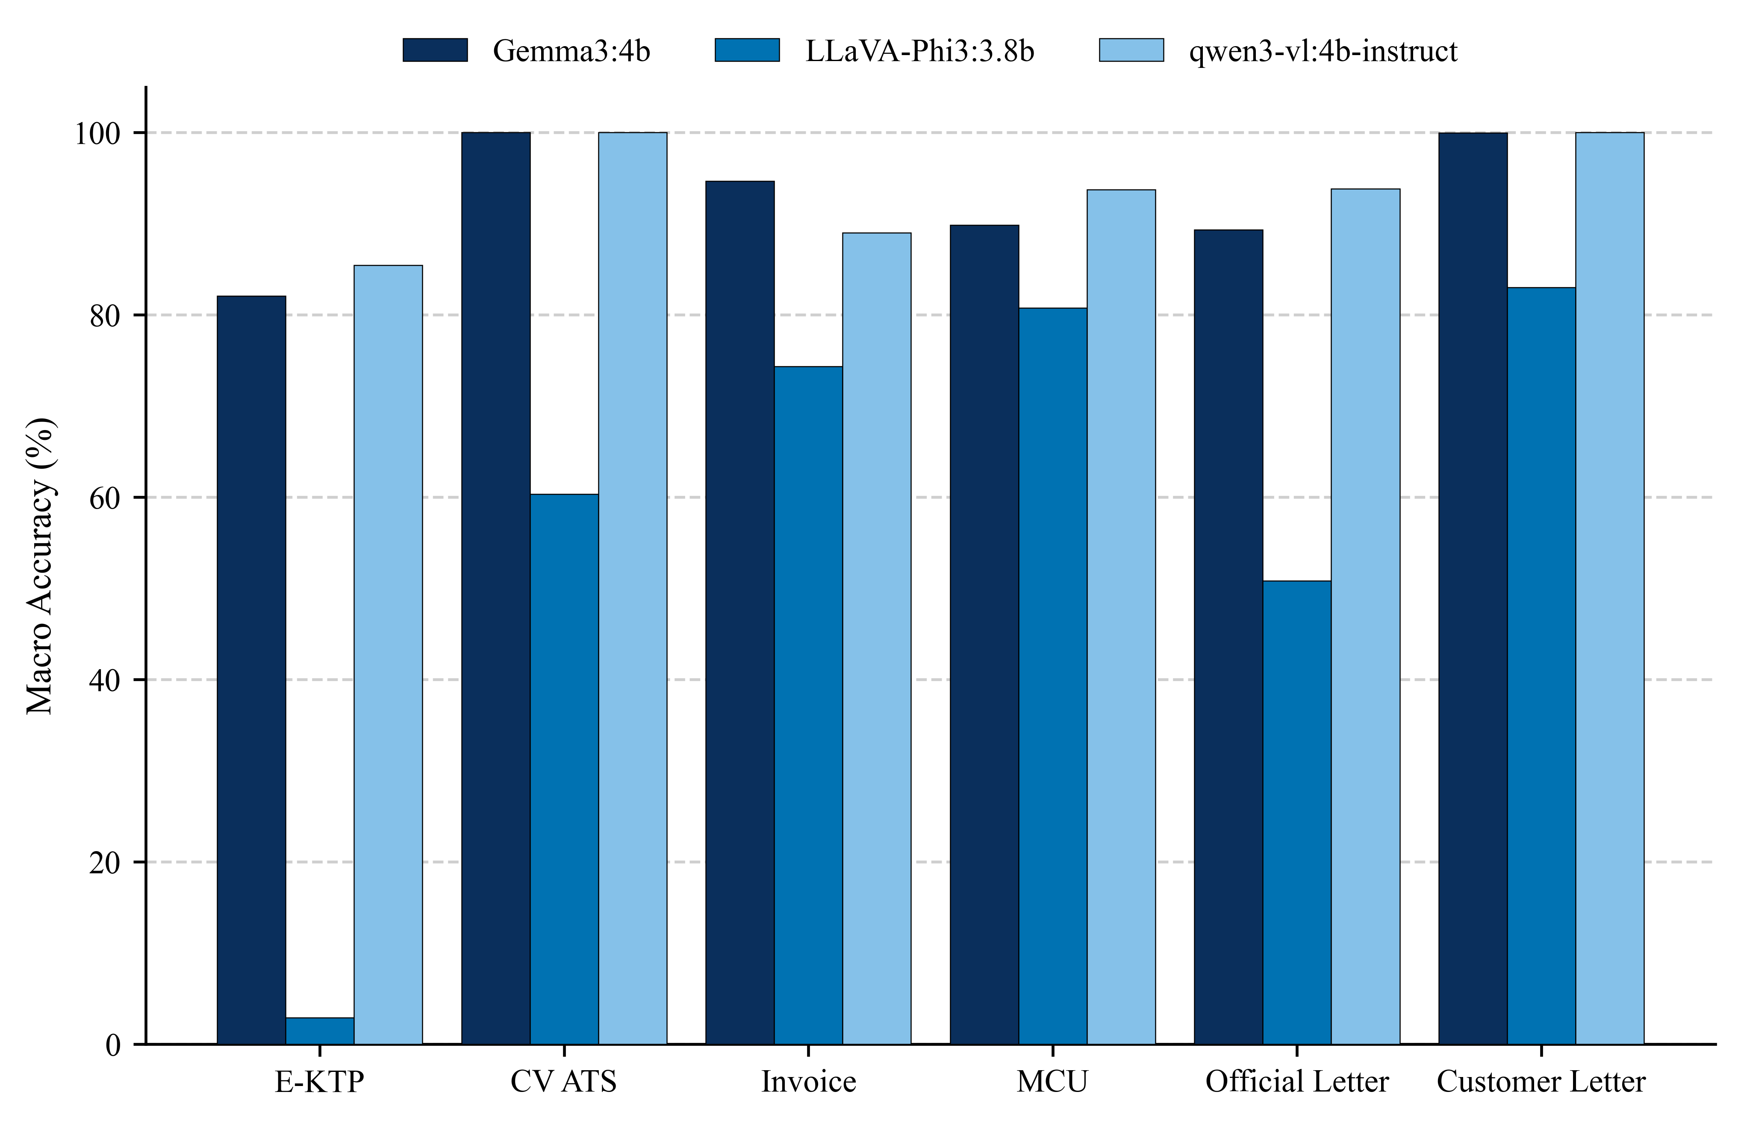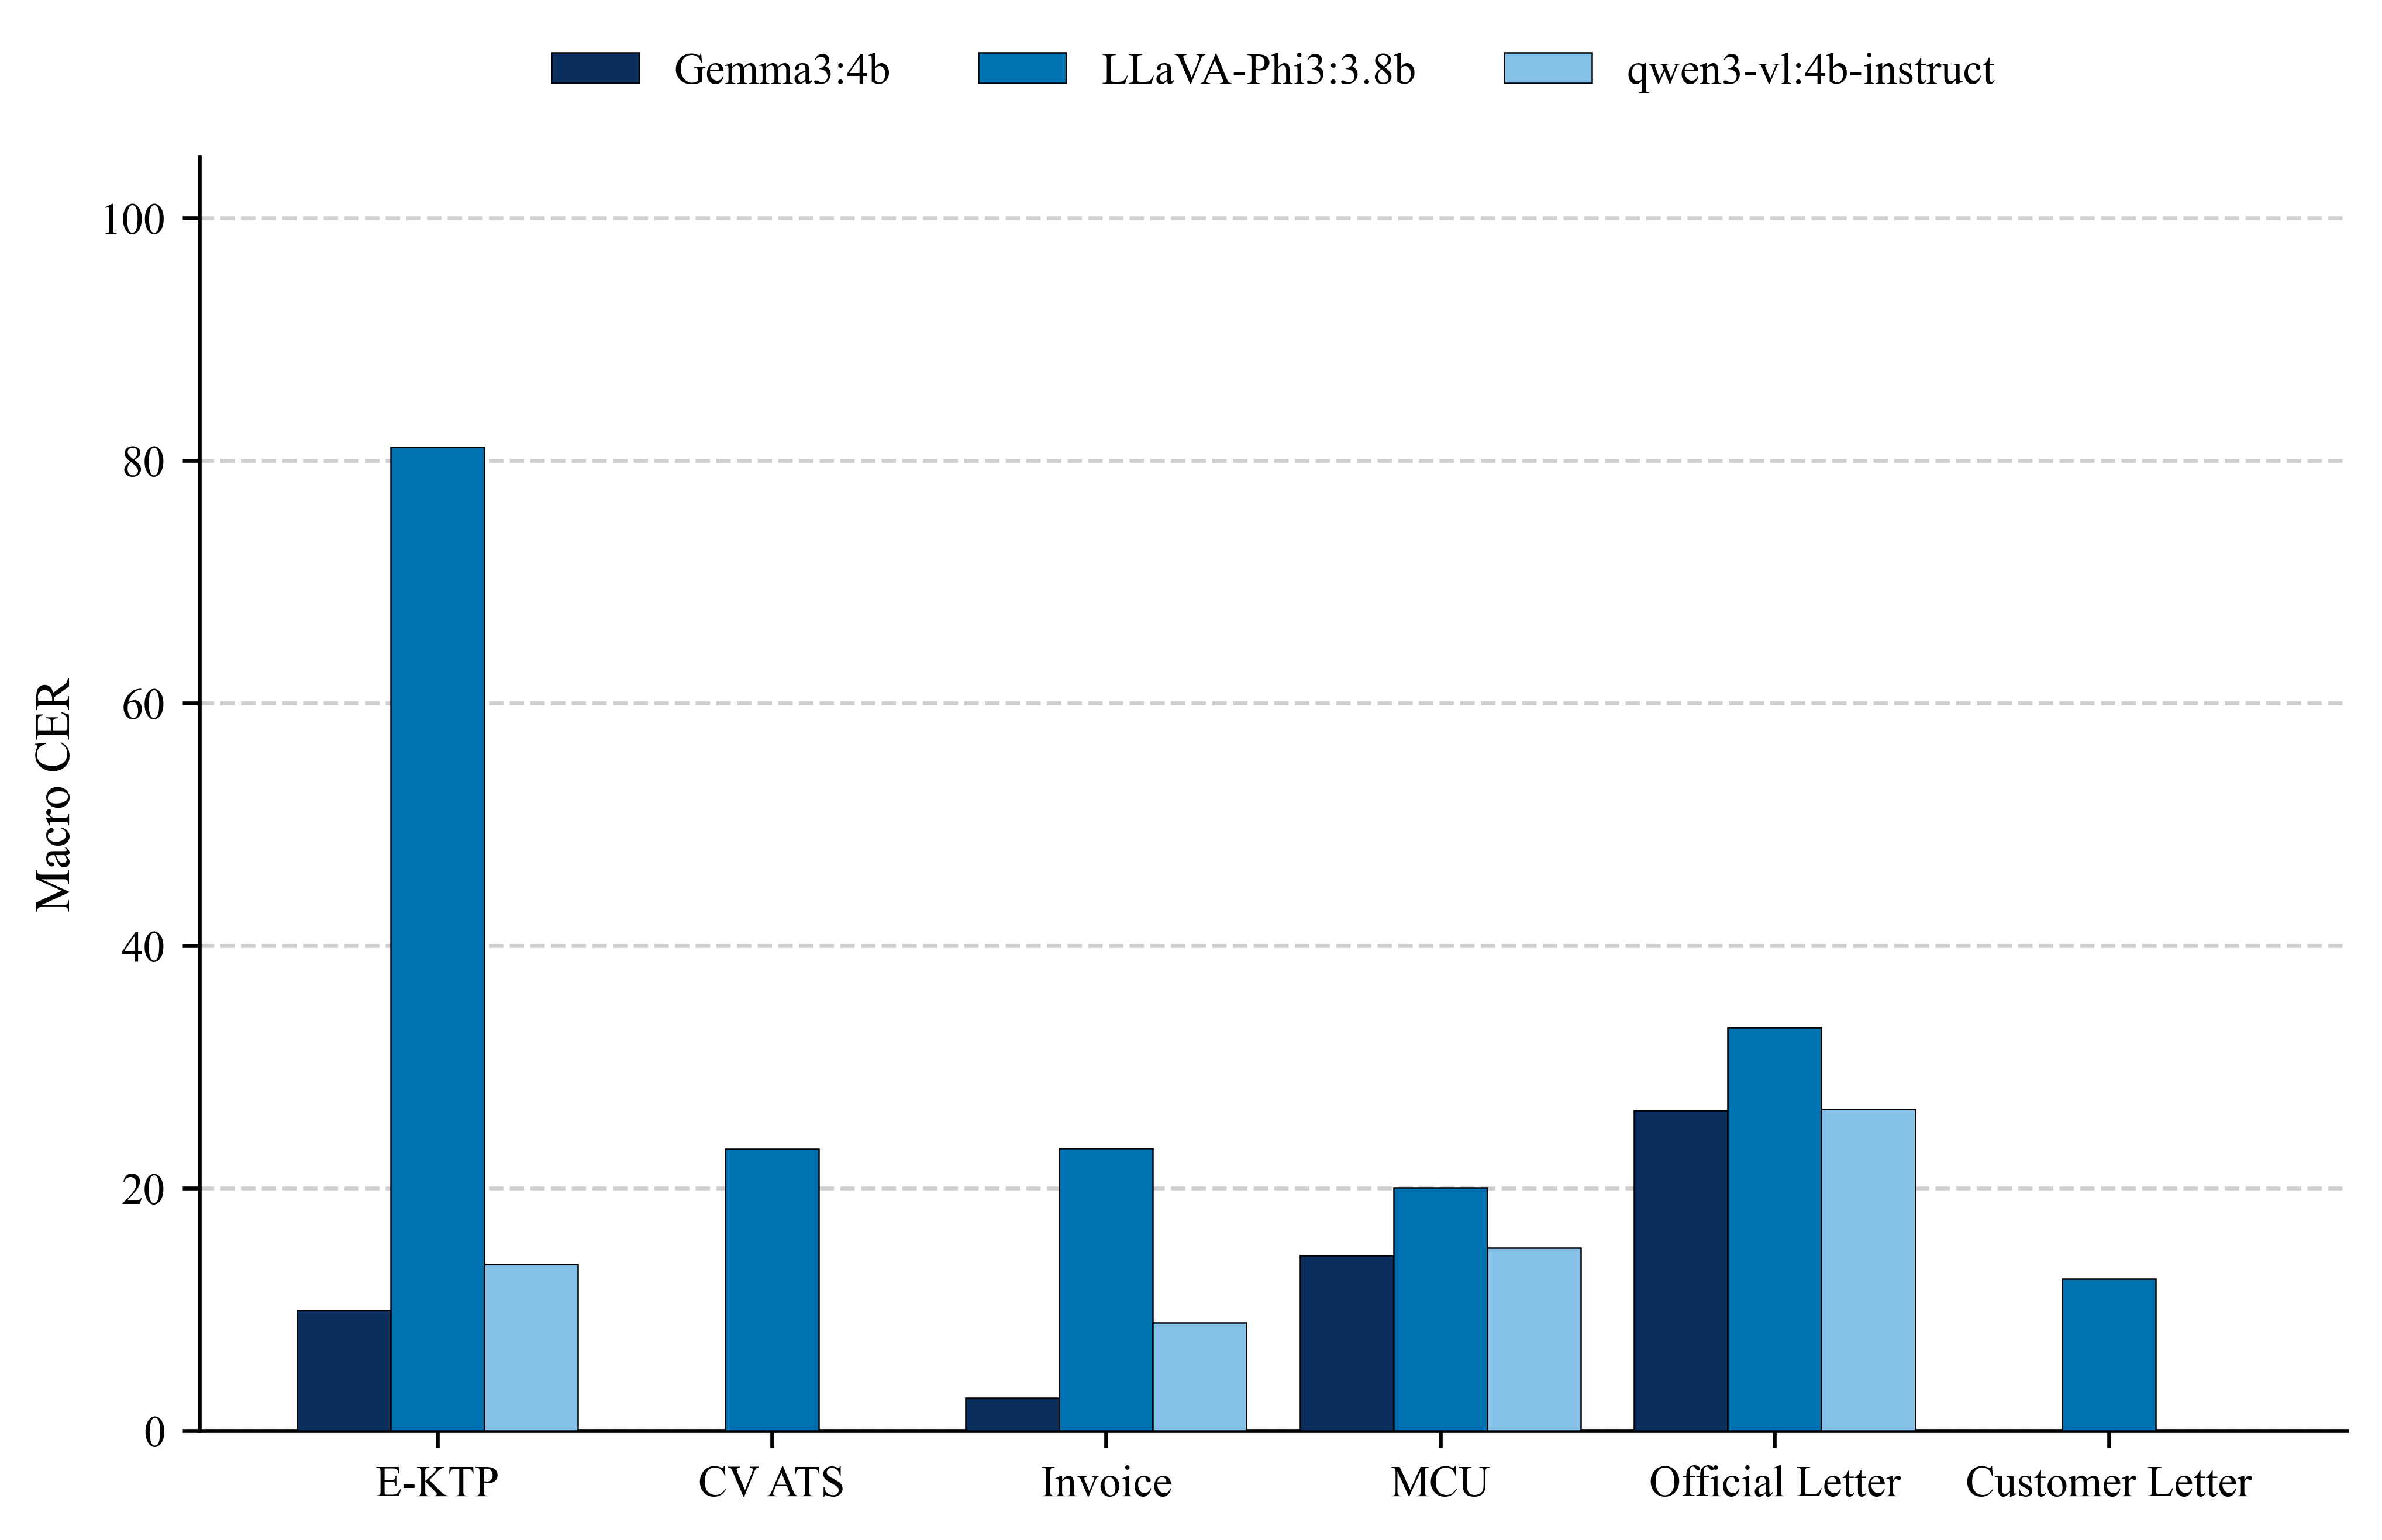
(a) (b)
Figure 7. Text Extraction Accuracy Comparison of VLMs for (a) Macro Accuracy and (b) Macro CER

3.2. Contextual PII Sanitization Efficacy
The transition from text extraction to the complex semantic reasoning required for sanitizing Personally Identifiable Information (PII) inherently imposes a substantial computational burden on VLMs. As summarized in Table 2, this advanced task triggers significant changes in resource utilization patterns. Although LLaVA-Phi3:3.8b maintained relatively stable latency (4.66 seconds on average, with a maximum of 13.57 seconds) and moderate VRAM consumption (4,797 MB on average, peaking at 4,847 MB), this efficiency contrasted sharply with Gemma3:4b’s instability. Gemma3:4b experienced the highest latency spikes (4.88 seconds on average, with a maximum of 17.49 seconds), despite recording the most efficient VRAM usage (4,669 MB on average, peaking at 4,769 MB). In contrast, although Qwen3-VL:4b-Instruct achieved the fastest processing speed (4.29 seconds on average, with a maximum of 13.58 seconds), it exhibited a heavy computational load when handling complex instructions. VRAM consumption increased sharply, requiring the largest allocation (9,069 MB on average, peaking at 9,547 MB)—nearly doubling the resource requirements of the preceding extraction phase. This memory surge poses a critical constraint for usage in memory-limited edge environments. However, the high computational cost may be acceptable if the model achieves an optimal balance between privacy protection and data utility. Therefore, this evaluation further analyzes this trilemma through sanitization effectiveness, as illustrated in Figure 8.

Table 2. Computational Efficiency of VLMs in PII Sanitization
Variable | Latency (s) (Avg / Max) | VRAM Usage (MB) (Avg / Peak) | CPU (%) & RAM (MB) (Avg)
Gemma3:4b | 4.88 / 17.49 | 4669 / 4769 | 4.8% / 16351
LLaVA-Phi3:3.8b | 4.66 / 13.57 | 4797 / 4847 | 4.5% / 15033
Qwen3-VL:4b-Instruct | 4.29 / 13.58 | 9069 / 9547 | 4.4% / 15817

Figure 8 evaluates sanitization quality by balancing Global Mask Recall (Figure 8a) and Global Non-target Preservation (Figure 8b). This balance matters because higher scores on both measures indicate better masking of sensitive PII without increasing overmasking risk. In the CV ATS and Customer Letter document tests, Qwen3-VL:4b-Instruct achieved the highest scores, with (Global Mask Recall, Global Non-target Preservation) metrics of (100.0%, 50.0%) and (100.0%, 98.8%), respectively. Gemma3:4b produced nearly identical results, matching the same mask recall with close preservation rates of (100.0%, 50.0%) on the CV ATS and (100.0%, 97.4%) on the Customer Letter. In contrast, LLaVA-Phi3:3.8b experienced a drastic sanitization failure on both documents, achieving only (4.0%, 49.5%) for the CV ATS and (4.0%, 43.2%) for the Customer Letter. Furthermore, for the Medical Check-Up (MCU) and Invoice documents, Qwen3-VL:4b-Instruct continued to achieve the highest scores, with results of (99.0%, 23.0%) for MCU and (100.0%, 91.5%) for Invoice. Gemma3:4b showed a similar pattern, with nearly identical results and close preservation rates of (98.0%, 18.5%) for MCU and (100.0%, 89.5%) for Invoice. In contrast, LLaVA-Phi3:3.8b performed poorly on MCU (5.2%, 3.5%) and completely failed to sanitize the Invoice document (0.0%, 47.5%). The same pattern appeared in the Official Letter and E-KTP documents. Qwen3-VL:4b-Instruct consistently achieved the highest scores, with results of (100.0%, 61.0%) for Official Letter and (99.0%, 89.9%) for E-KTP. Gemma3:4b maintained high scores for Official Letter (95.8%, 51.6%) but declined for E-KTP (85.2%, 63.7%). Meanwhile, LLaVA-Phi3:3.8b showed improved mask recall for Official Letter (17.8%, 3.7%) and E-KTP (73.1%, 0.7%), but these gains came with a significant decline in preservation rates. The failure of LLaVA-Phi3:3.8b confirms the effect of error propagation; poor text extraction, as shown in Subsection 3.1, impairs the model’s contextual reasoning and triggers overmasking that compromises non-target data preservation. Meanwhile, overmasking in MCU documents results from a privacy bias toward health data. Clinical parameters trigger an overgeneralization of censorship into medical observation contexts, consistent with language models’ tendency to apply safeguards beyond their original scope when encountering clinical contexts [8]. Based on Computational Efficiency (Table 1), PII Sanitization Mask Recall (Figure 8a), and Non-target Preservation (Figure 8b), this Phase 2 evaluation demonstrates that, by combining the lowest VRAM consumption with the highest Mask Recall and Non-target Preservation across various document formats, Gemma3:4b is the optimal solution for pre-inference sanitization systems in edge computing environments.

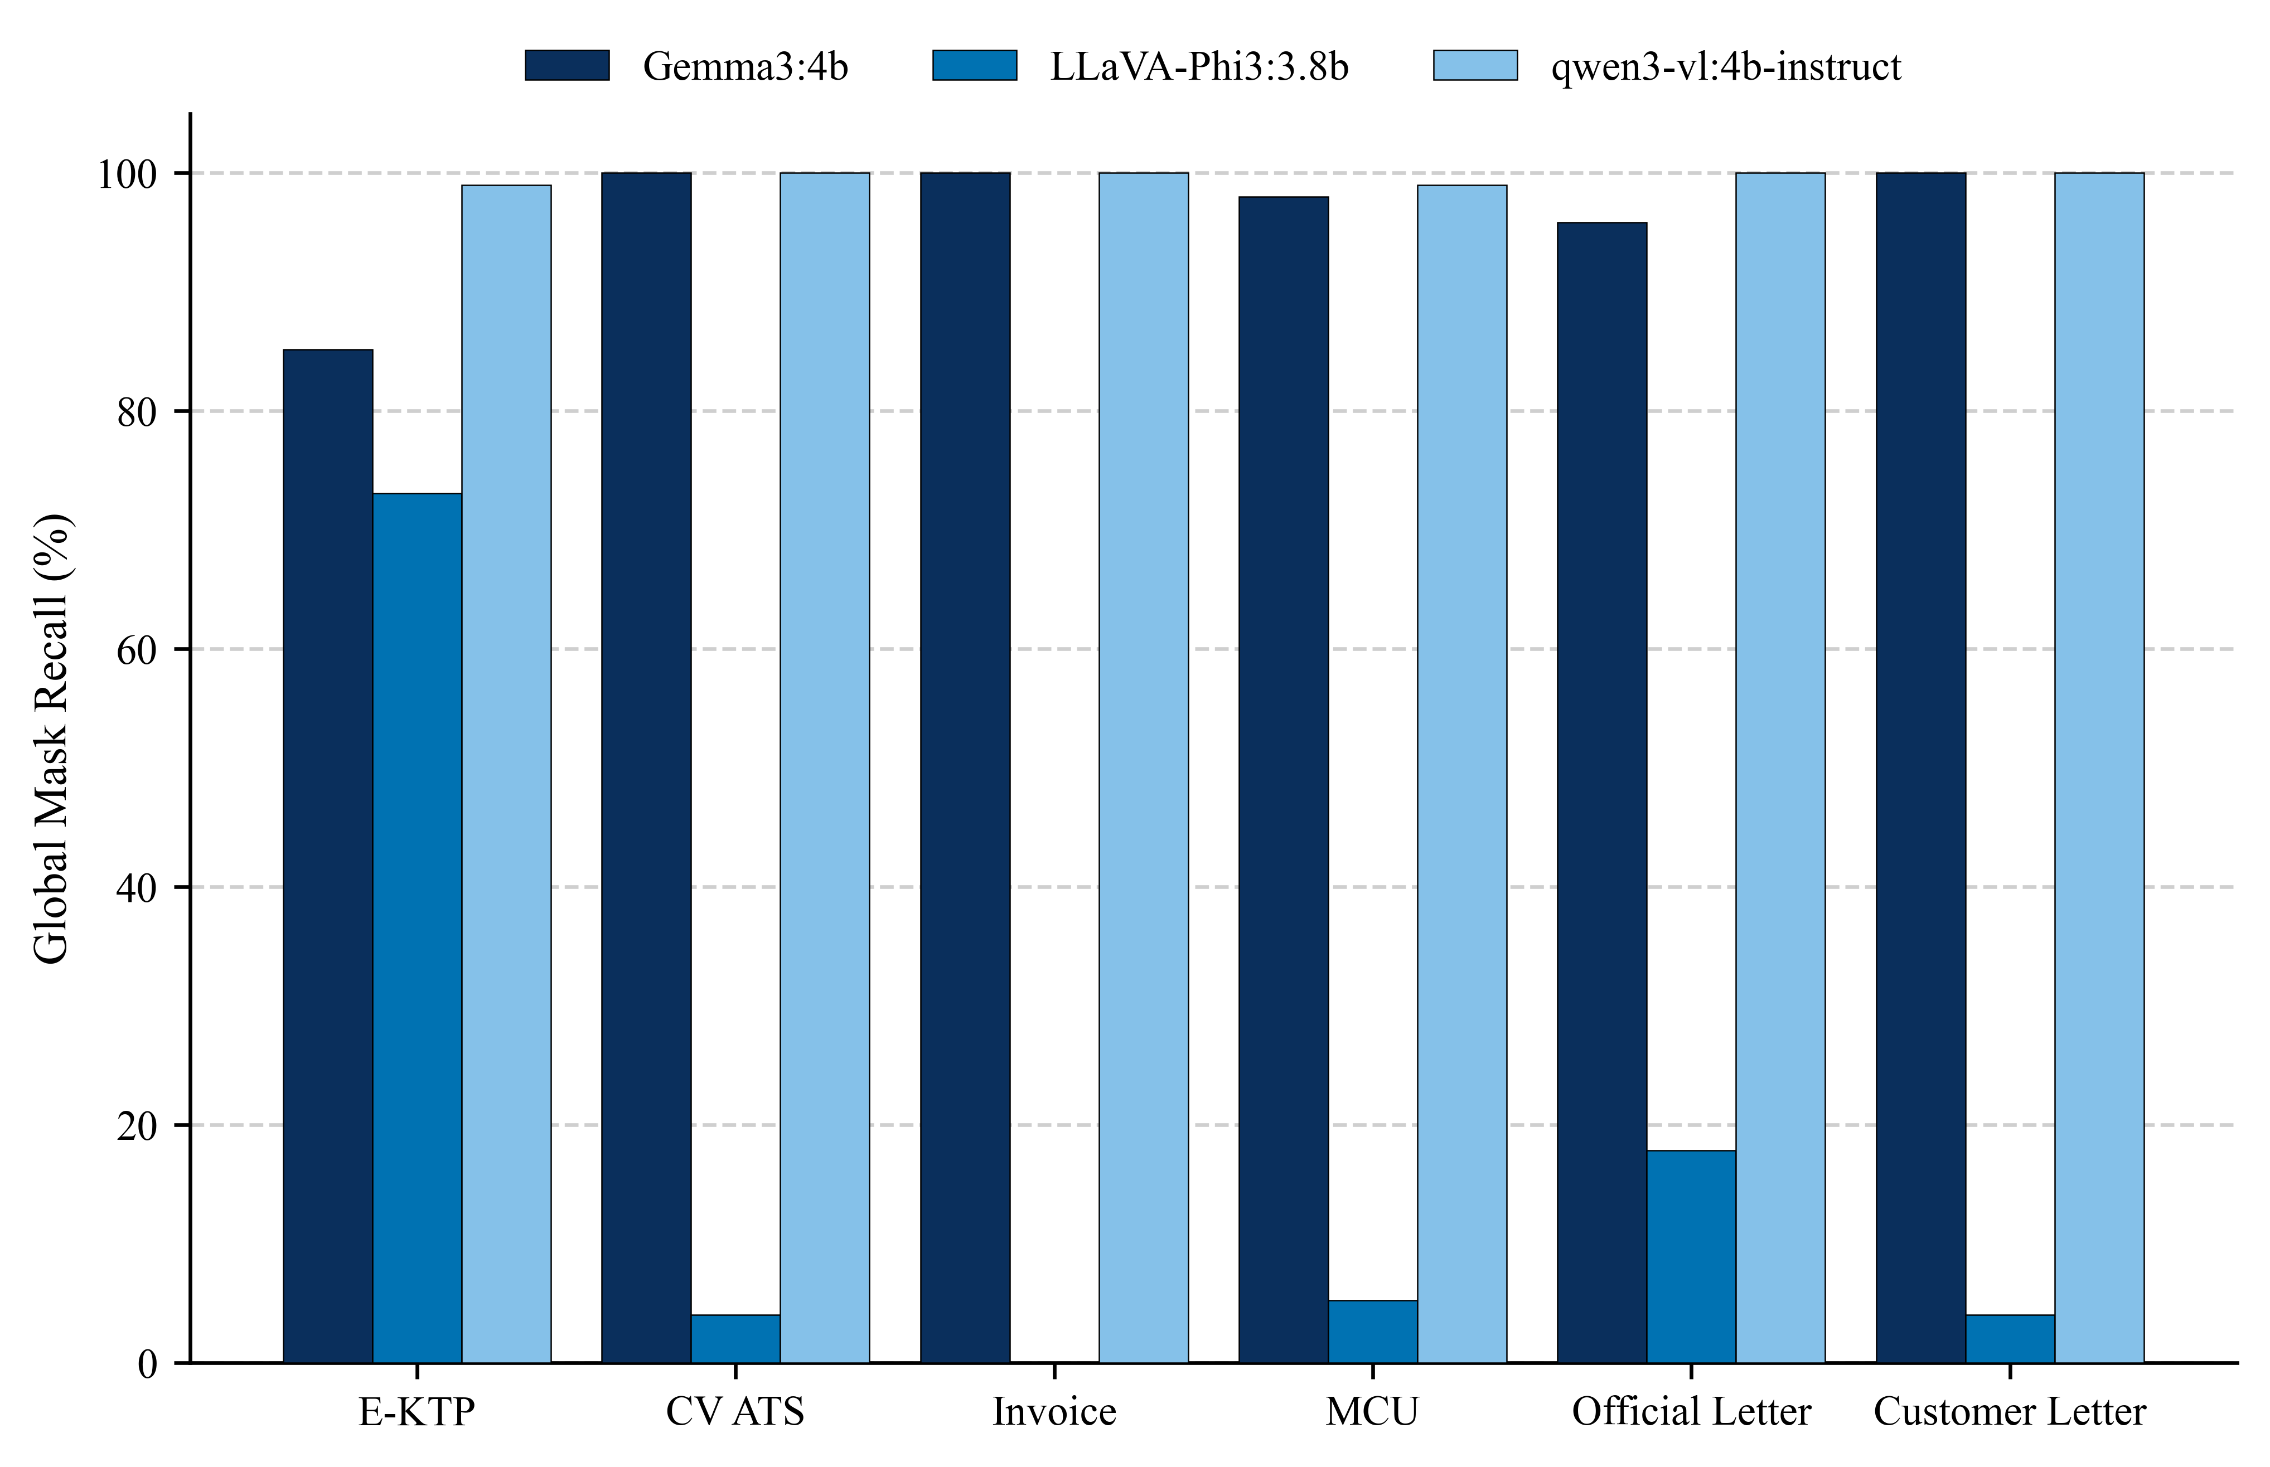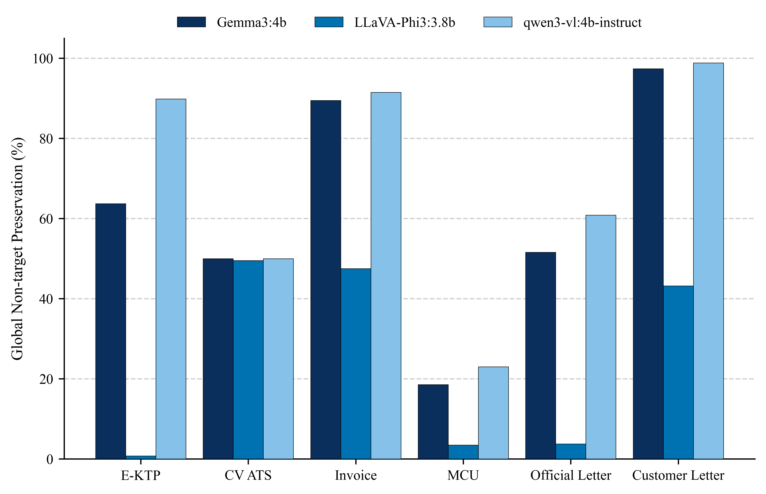
(a) (b)
Figure 8. PII Sanitization Accuracy Comparison of VLMs for (a) Global Mask Recall and (b) Global Non-Target Preservation

3.3. Trade-off Analysis and Best Model Selection
To formulate a holistic architectural decision from the evaluation results of the extraction and sanitization phases, Figure 9 maps the evaluated models onto a two-dimensional trade-off space by comparing Composite Score (Quality Benefit) against Resource Cost. This visualization eliminates LLaVA-Phi3:3.8b as an option. In the lowest quadrant, the model reaches only a 33.6% composite score and fails to meet the acceptable quality threshold despite requiring 5,666.0 MB of peak VRAM. By contrast, Qwen3-VL:4b-Instruct achieved the highest semantic accuracy, with a composite score of 87.4%; however, its position at the end of the computational spectrum—with peak memory consumption of 9,547.0 MB—makes it unsuitable for usage on memory-constrained edge devices. Accordingly, Gemma3:4b emerges as the only model on the optimal Pareto front, offering an excellent balance with a composite score of 83.6% while maintaining the lowest resource consumption at 5,061.0 MB. Based on this spatial analysis, Gemma3:4b was selected as the primary model for the pre-inference sanitization pipeline because it successfully meets the dual requirements of reliable data fidelity and hardware efficiency.

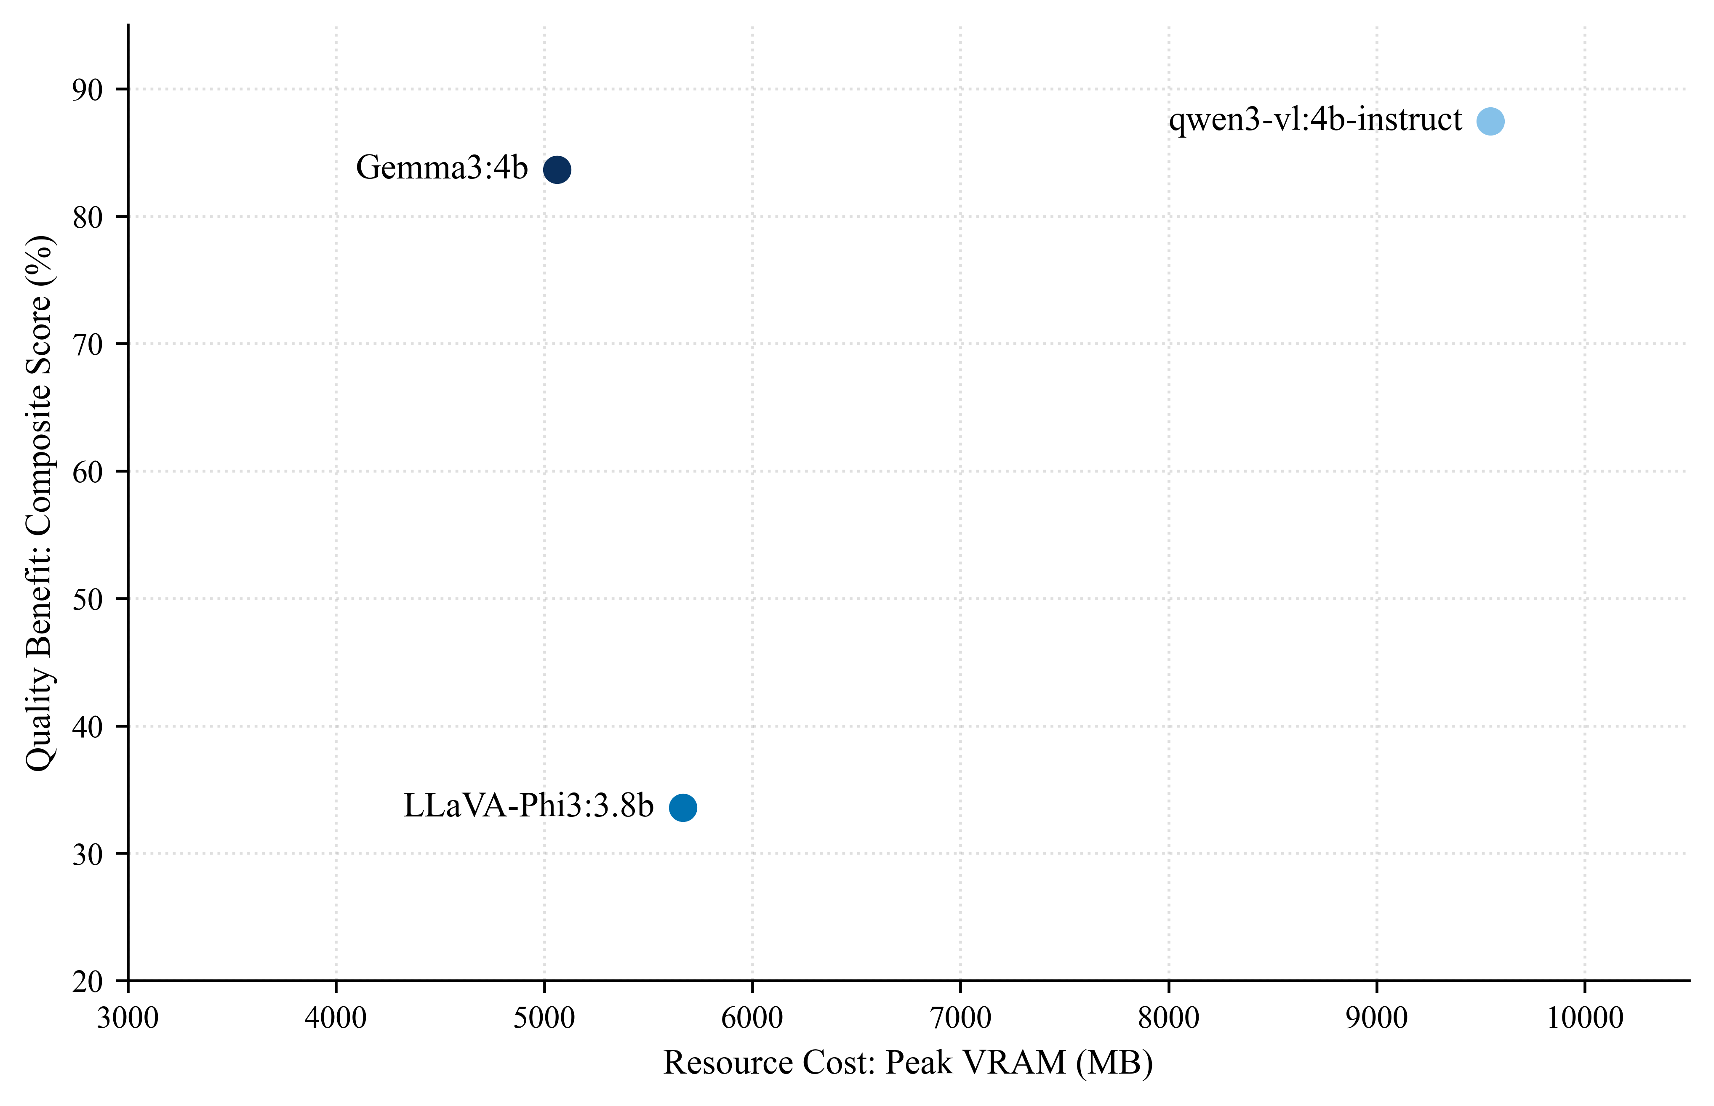
Figure 9. Performance and Efficiency Trade-off Analysis of VLMs

3.4. Application Implementation: SanitiX AI
To implement Gemma 3:4B’s Pareto-optimal advantage in an edge computing environment, the model was integrated as a pre-inference sanitization engine (Worker 1) in the SanitiX AI application prototype. As illustrated in Figure 10, the user interface displays a dual-worker architecture, assigning Gemma 3 (4B) as the local sanitization agent and Mistral Small Latest as the primary inference engine (Main LLM). The Logs & PII Protection panel serves as a verification mechanism for monitoring pipeline activity in real time. This interface was designed to promote transparency and user trust in the locally executed privacy protection mechanism.

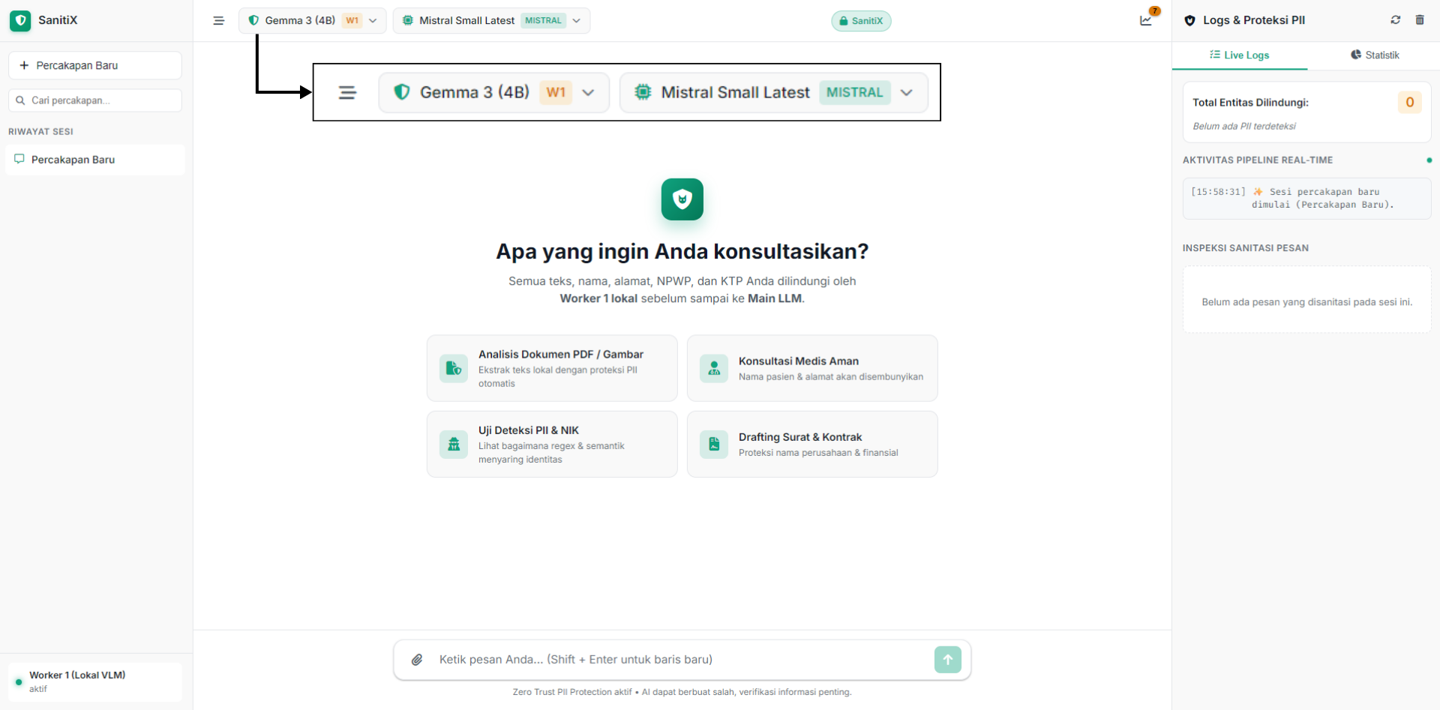
Figure 10. The SanitiX AI user interface featuring the dual-worker architecture and real-time transparency logs

Figure 11 presents a proof of concept of the system’s real-time execution. The user uploads an image of a synthetic E-KTP along with instructions to summarize its contents. The Logs & PII Protection panel shows that Worker 1 successfully extracted text from the visual document and intercepted PII entities in the E-KTP. The system then modifies the payload by replacing PII entity data with mask tags representing their respective categories—such as [MASKED:NIK], [MASKED:PERSON], [MASKED:RT_RW], and [MASKED:PEKERJAAN]—before forwarding the data to the Main LLM. The sanitized payload received by the Main LLM (Mistral) enables it to summarize the remaining non-target information without any loss of context. This process validates that the SanitiX AI architecture can minimize the risk of data leakage while preserving the language model’s semantic utility.

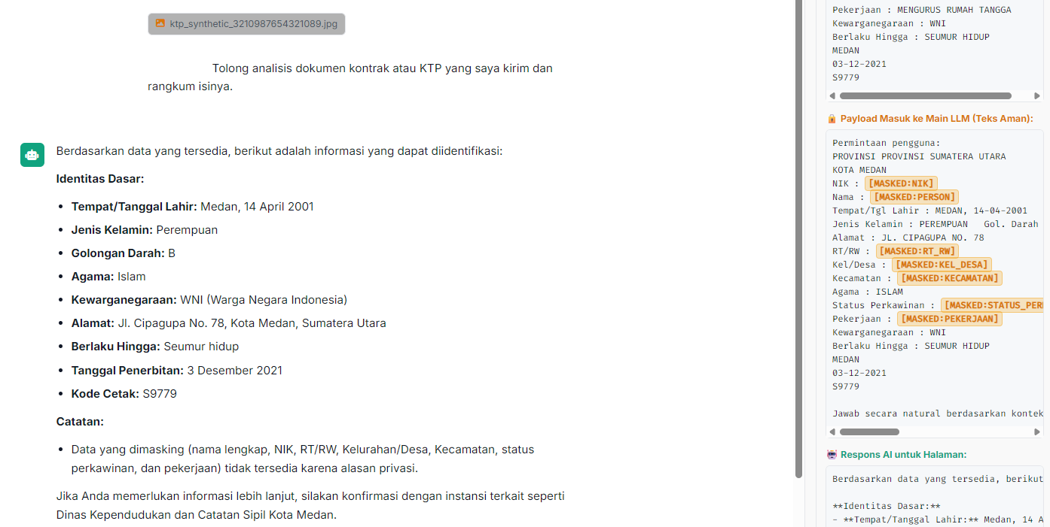
Figure 11. Real-time PII sanitization proof showcasing payload interception by Worker 1 and context retention by the Main LLM

- CONCLUSION
The experimental results indicate a significant trade-off between privacy protection effectiveness and computational resource costs in pre-inference sanitization architectures within edge computing environments. Based on the evaluation, Qwen3-VL:4b-Instruct delivered the highest analytical performance, with a Composite Score of 87.4%. However, this model requires substantial memory allocation, with peak VRAM usage of 9,547 MB, making it less suitable for resource-constrained devices. In contrast, Gemma3:4b proved to be the most efficient model and achieved a Pareto-optimal position. It maintained a competitive Composite Score of 83.6% while reducing peak VRAM consumption to 5,061 MB. By comparison, LLaVA-Phi3:3.8b demonstrated the lowest performance, with a Composite Score of only 33.6%, and experienced a decline in visual text extraction accuracy on the E-KTP dataset (2.9%). This decline empirically confirms its vulnerability to unstructured noise and the risk of error propagation. These findings underscore the critical importance of aligning model selection with hardware constraints. The implementation of Gemma3:4b in the SanitiX AI prototype proved capable of establishing an effective privacy protection architecture by intercepting PII entities locally without compromising the Main LLM’s semantic context utility. Therefore, future research should focus on optimizing this balance, particularly to mitigate overmasking anomalies in documents containing dense clinical terminology, such as Medical Check-Up (MCU) documents, through domain-specific fine-tuning and the exploration of existing models already specialized for PII sanitization tasks.

REFERENCES
[1] Z. Shi et al., “From machine learning to multimodal models: The AI revolution in enzyme engineering,” BioDesign Res., vol. 8, no. 1, p. 100044, 2026, doi: 10.1016/j.bidere.2025.100044.
[2] S. Shahriar, R. Dara, B. Lund, and M. Kamali, “A comparative study on textual and multimodal PII detection using large language models,” Comput. Stand. Interfaces, vol. 99, no. March 2026, p. 104185, 2027, doi: 10.1016/j.csi.2026.104185.
[3] X. Ye, J. Yu, J. Li, and Y. Zhao, “CMAT: A cross-model adversarial texture for scanned document privacy protection,” Appl. Soft Comput., vol. 188, no. December 2025, p. 114353, 2026, doi: 10.1016/j.asoc.2025.114353.
[4] X. Zhang, A. David, H. Isah, and H. Cavusoglu, “Personally identifiable information detection in smart edge computing: A robust model evaluation,” Knowledge-Based Syst., vol. 328, no. September 2024, p. 114153, 2025, doi: 10.1016/j.knosys.2025.114153.
[5] H. Gorskis, J. Strebko, J. Korņijenko, V. Zabiņako, and A. Romanovs, “A Hybrid Approach to the Automatic Detection of Personal Data in Latvian-Language Texts,” Futur. Internet, vol. 18, no. 7, 2026, doi: 10.3390/fi18070354.
[6] D. Venditti et al., “Enhancing Data Privacy in Large Language Models Through Private Association Editing,” J. Cybersecurity Priv., vol. 6, no. 3, pp. 1–33, 2026, doi: 10.3390/jcp6030096.
[7] C. Alfieri, G. L. Scoccia, S. Ganesh, and N. Sadeh, “Applying large language models to sanitize self-disclosure in user-generated content,” Appl. Soft Comput., vol. 181, no. May, p. 113311, 2025, doi: 10.1016/j.asoc.2025.113311.
[8] M. Sariyar, “Clinical Text De-Identification Beyond PHI Detection : A Scoping Review,” 2026.
[9] S. A. C. Ordóñez, J. Samanta, and A. L. Suárez-cetrulo, “Intelligent Edge Computing and Machine Learning : A Survey of Optimization and Applications,” 2025.
[10] N. Journet and A. Billy, “DocCreator : A New Software for Creating Synthetic Ground-Truthed Document Images”, doi: 10.3390/jimaging3040062.
[11] D. V Polevoy et al., “Document Liveness Challenge Dataset ( DLC-2021 ),” pp. 1–12, 2022.
[12] Y. Matsuo, Y.; Aoki, “Synthetic Document Images with Diverse Shadows for Deep,” 2024.
[13] A. Ibrahim, A. Khalili, M. Arabi, A. Sattar, A. Hosseini, and A. Serag, “MERA : Medical Electronic Records Assistant,” pp. 1–19, 2025.
[14] G. Balaskas, H. Papadopoulos, D. Pappa, and Q. Loisel, “A Framework for Domain-Specific Dataset Creation and Adaptation of Large Language Models,” pp. 1–22, 2025.
[15] T. Zheng, S. Shen, and C. Zeng, “A Retrieval-Augmented Generation Method for Question Answering on Airworthiness Regulations,” pp. 1–18, 2025.
[16] W. Khallouli, M. S. Uddin, A. Sousa-poza, and J. Li, “Leveraging Transformer-Based OCR Model with Generative Data Augmentation for Engineering Document Recognition †,” pp. 1–22, 2025.
[17] S. Asiri, R. Alshehri, F. Kamran, H. Laznam, Y. Xiao, and S. Alzahrani, “SPADR : A Context-Aware Pipeline for Privacy Risk Detection in Text Data,” pp. 1–30, 2025.
[18] L. Chen, H. Weng, M. S. Pardeshi, C. Chen, R. Sheu, and K. Pai, “Evaluation of Prompt Engineering on the Performance of a Large Language Model in Document Information Extraction,” pp. 1–26, 2025.
[19] P. Rojas-carrasco and M. Guinaldo, “Multi-Objective Evaluation of Lightweight AI Models on Low-Cost Edge Devices Using Pareto Fronts,” pp. 1–21, 2026.

